The Reversing task 1

The file provided is an excutable file in machine language that’s or partial binary   
 To get a detail idea of the excutable file we can use Online decompliers which decompile the excutable file using different sources such as gidra ,binary ninja

The best source to use inbuit code reverser are Gdb and external application such as IDA

GDB consider for linux based debugger in Assembly   
IDA consider for Windows

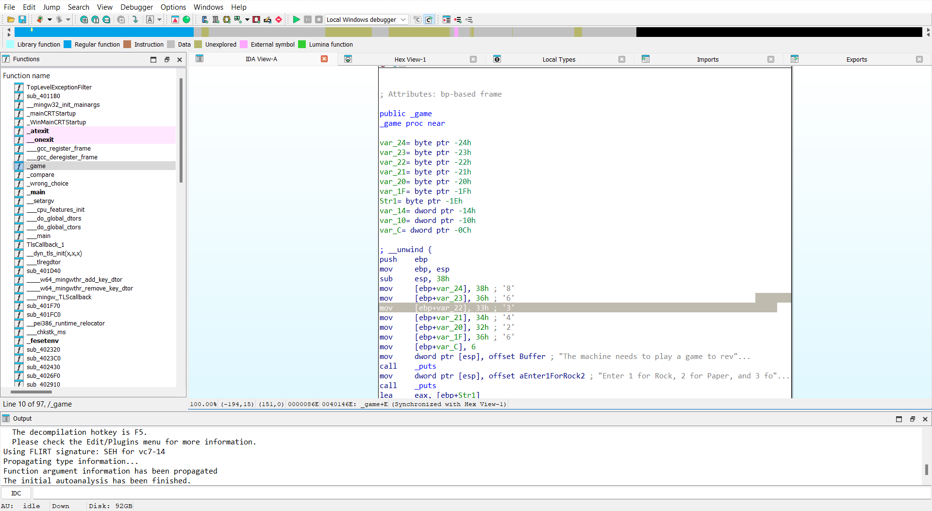

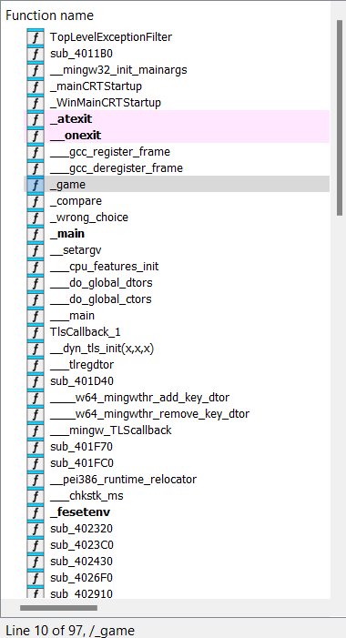

The left most sector determine Function name  
Right determine the excuation of code in assemble and bottom is output sector

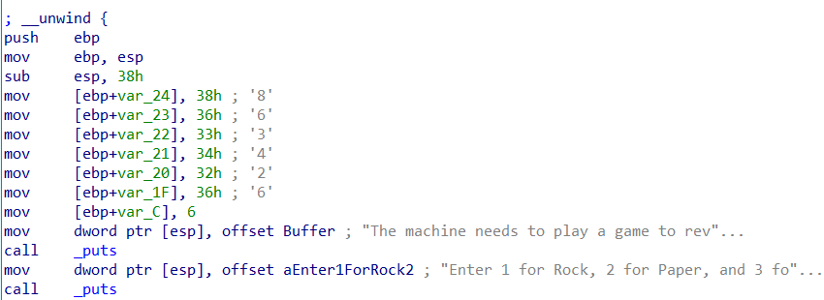

This determine the elements in the array and that’s the superkey for event stored as characters

Press F5 to decompile the excutable file of any function

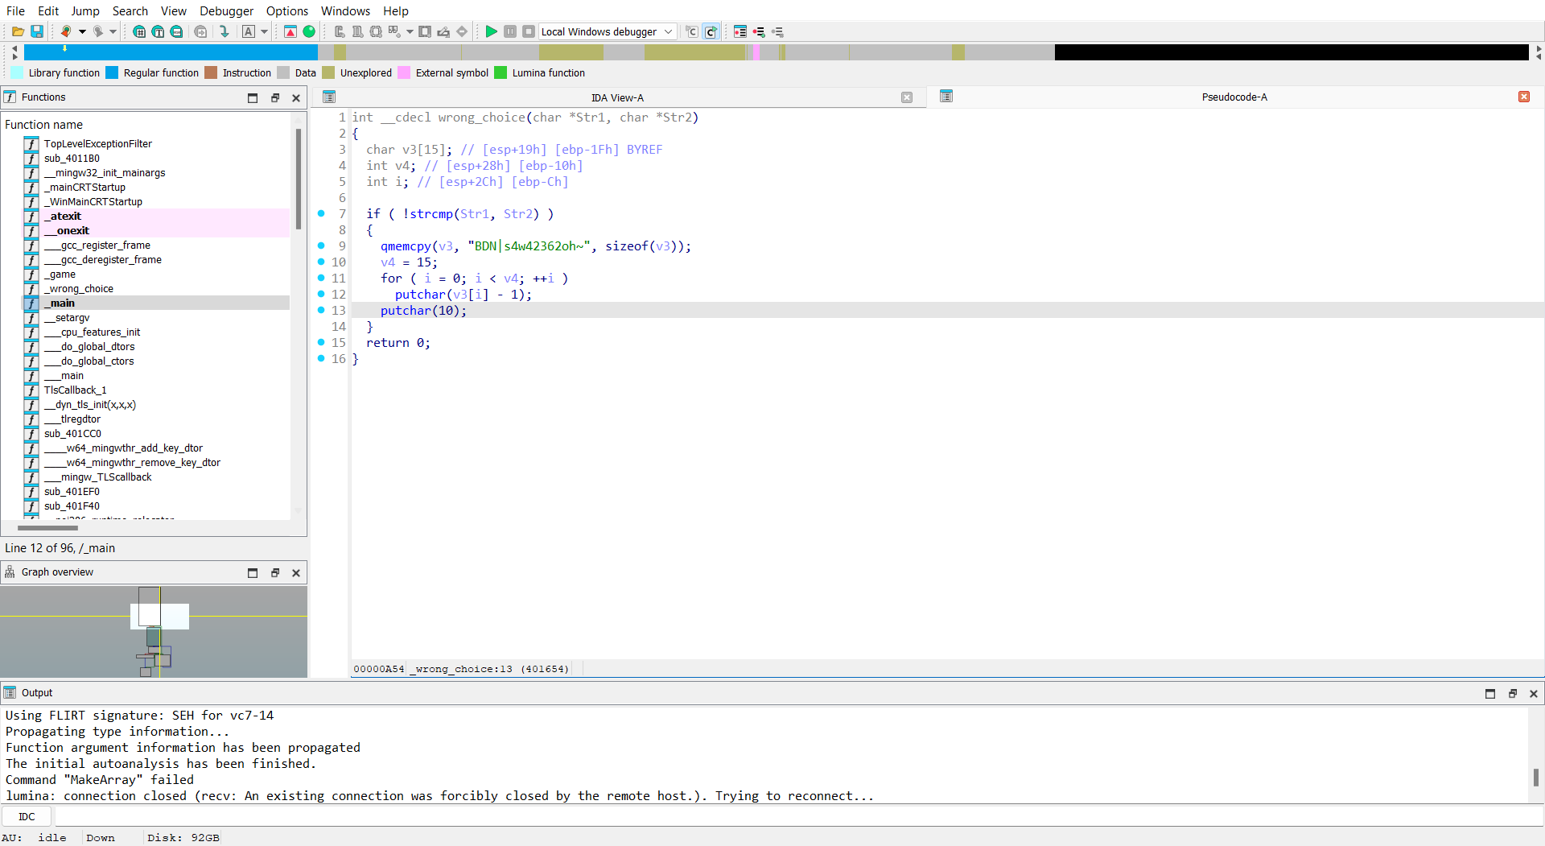

Source code of Excuatble in C of main() Select the function to find to Decompiled Form of fucntion